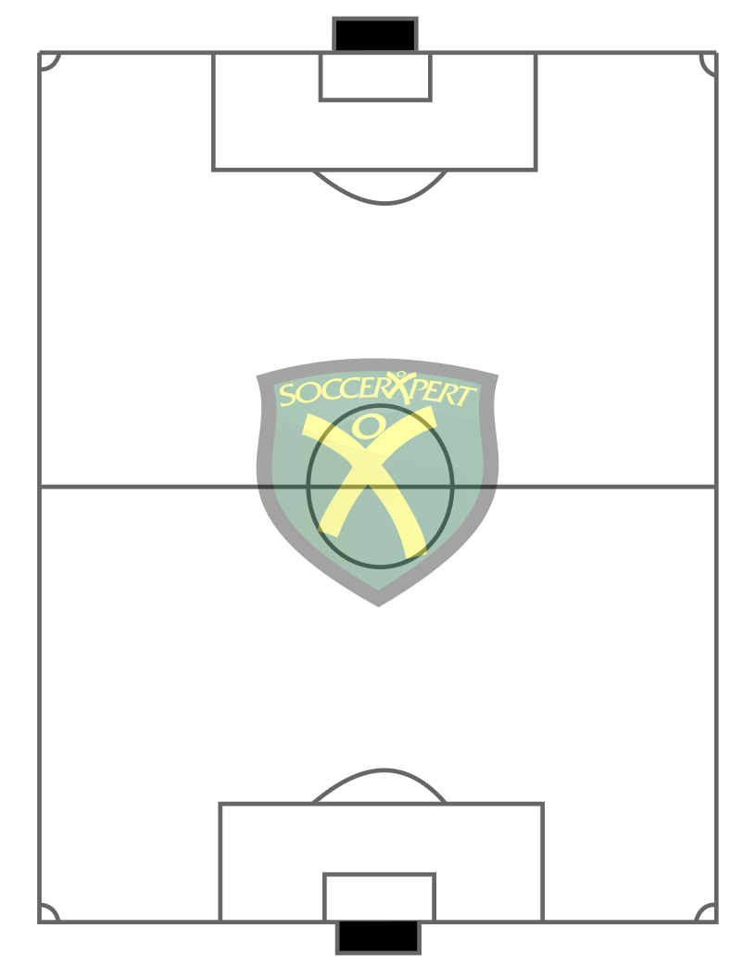
1st Half Lineup 2nd Half Lineup
Player Position Time Player Position Time
1. ______________________________________ 1. ______________________________________
2. ______________________________________ 2. ______________________________________
3. ______________________________________ 3. ______________________________________
4. ______________________________________ 4. ______________________________________
5. ______________________________________ 5. ______________________________________
6. ______________________________________ 6. ______________________________________
7. ______________________________________ 7. ______________________________________
8. ______________________________________ 8. ______________________________________
9. ______________________________________ 9. ______________________________________
10.______________________________________ 10._______________________________________
11.______________________________________ 11._______________________________________
SUBSTITUTIONS SUBSTITUTIONS
GAME NOTES GAME NOTES

